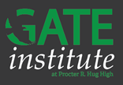

***Don’t Miss Out!***

**Applications are available online from November 1st – January 1st!**

<https://www.washoeschools.net/Page/13962>

**The GATE Institute, *a collaboration between the GATE program, Hug High School, and AP Capstone,* offers gifted and talented students a unique experience to fit the whole student.**

* **AP Capstone Diploma**
* **Individualized Programing & Scheduling**
* **Advanced Academic Pathways**
* **GT Endorsed Teachers**
* **Dual-Enrollment in the Health Science Academy**
* **One to One Technology**
* **Diverse Music Program**
* **NIAA Athletic Participation**

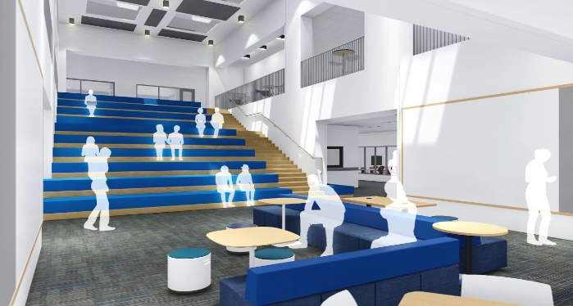**What is AP Capstone?**  
The College Board’s AP Capstone is an innovative and engaging ***college-level program for high school students*** that complements and enhances discipline-specific AP courses. It’s built on two courses—***AP Seminar*** and ***AP Research.*** AP Capstone is the pinnacle of the high school experience, encouraging a passion for learning and transforming students into curious, collaborative, and independent thinkers with skills that are valued and sought after by colleges and universities.

**The GATE Institute is moving!**

**Upon completion of the new high school at Wildcreek, students enrolled in the GATE Institute will move with zoned students to the new school.**

**For more information, please see:**

<http://www.wcsdbuilding.com/wildcreek/>

**The Department of Gifted and Talented Education Program Office: 775-861-4451** [giftedandtalented@washoeschools.net](mailto:giftedandtalented@washoeschools.net)